GPARTED EXERCISE

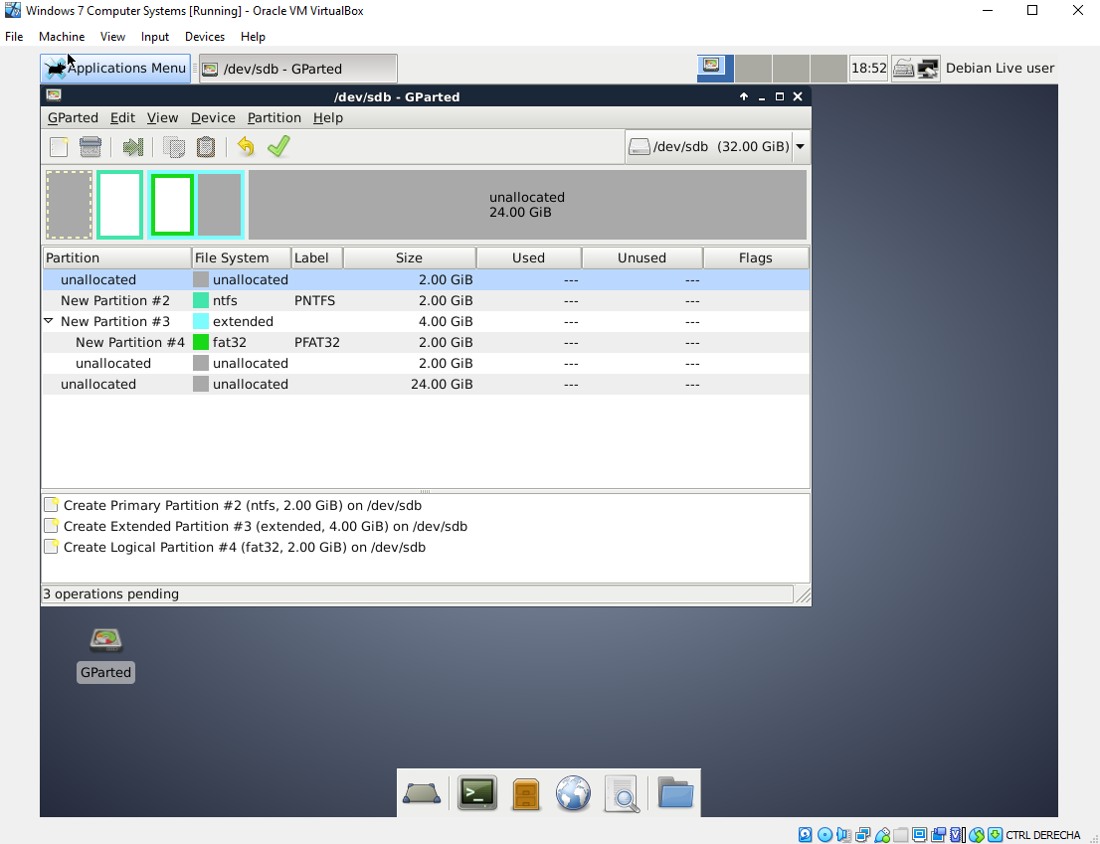
In a Windows 7 VM I’ve inserted the debian.iso live CD to access into GParted and make all the partitions thought Debian, because Windows don’t recognize some partitions like EXT4.

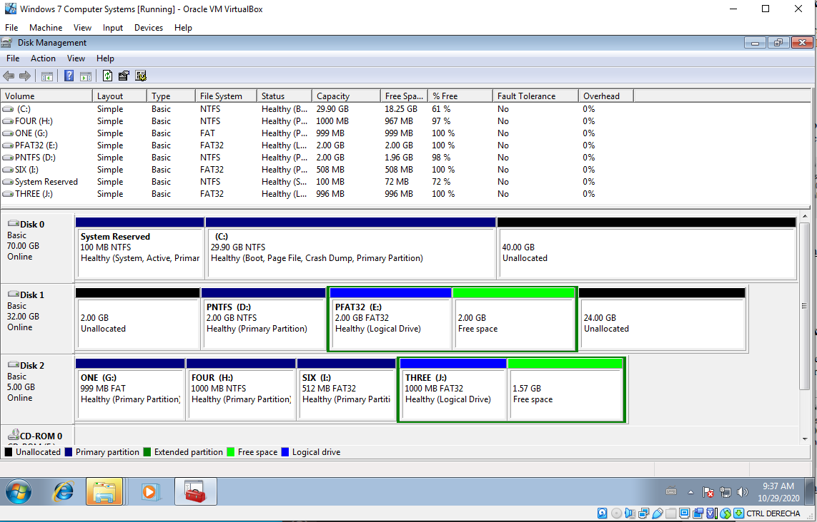
In the Windows 7 disk management program it’s not able to load those EXT4 partitions and it marks them as unallocated. In this case we have 40GB unallocated where an Ubuntu OS it’s installed, and the other unallocated spaces are those one that we created running the live Debian CD.

